**Database Design Report**

The database is about Specialist Clinic Reserving which patients can search for the information of doctors and make reservations. There are 4 tables, including patient, doctor, department, and appointment. The tools include ER Assistant for ER Diagram, MySQL.

The first step is that design the ER-Diagram by ER Assistant, including ‘DOCTOR’, ‘DEPARTMENT’, ‘PATIENT’ and ‘APPOINTMENT’ 4 entities. ‘APPOINTMENT’ is a weak entity because it depends if a patient makes it. A patient can make many appointments, but an appointment has only one patient. A doctor can have many appointments, but an appointment has only a doctor. A department has only a doctor in manager role, and a manager doctor only can manage a department. A department can have many doctors, but a doctor just can work for a department. Supervision relationships between doctor and doctor. One doctor in supervisor role can supervise many doctors, but a doctor just has a supervisor. Based on these ideas, the ER-Diagram is designed below:

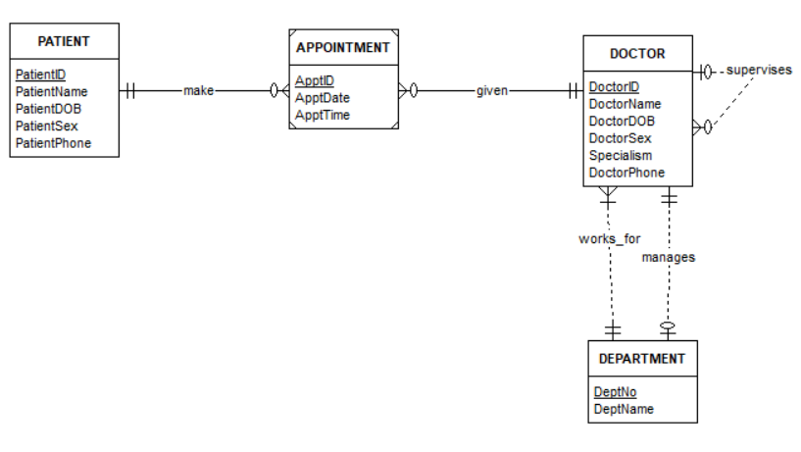

The next step is that design a relational database schema. For ER-Diagram, there are seven steps.

Step one: Mapping of Regular Entity Types, like ‘DOCTOR’, ‘DEPARTMENT’, ‘PATIENT’.

Step two: Mapping of Weak Entity Types, such as ‘APPOINTMENT’.

Step three: Mapping of Binary 1:1 Relation Types. For example, the relationship between ‘DOCTOR’ and ‘DEPARTMENT’. We should add ‘MgrID’ in the ‘DEPARTMENT’ schema.

Step four: Mapping of Binary 1:N Relation Types. For example, the relationship between ‘APPOINTMENT’ and ‘PATIENT’. We should add ‘PatientID’ in ‘APPOINTMENT’ as a foreign key.

Step five: Mapping of Binary M: N Relation Types.

Step six: Mapping of Multivalued attributes.

Step seven: Mapping of N-ary Relationship types. For example, the self-relationship of ‘DOCTOR’. We should add ‘SuperID’ in the ‘DOCTOR’ schema.

The final ER-to-Relational Mapping is below

DOCTOR(DoctorID, DoctorName, DoctorDOB, DoctorSex, Specialism, DoctorPhone, DNo, SuperID)

PATIENT(PatientID, PatientName, PatientDOB, PatientSex, PatientPhone)

DEPARTMENT(DeptNo, DeptName, MgrID)

APPOINTMENT(ApptID, ApptDate, ApptTime, DoctorID, PatientID)

After mapping, normalization for a relational database is the goal of evaluating relational schemas for design quality. In my database, the tables are already in 3NF.

Then, the tables need to transfer to the schemas by MySQL. Firstly, create the tables in ‘ClinicResschema’ SQL file. We should define types, primary key, and foreign key. Below is the explanation,

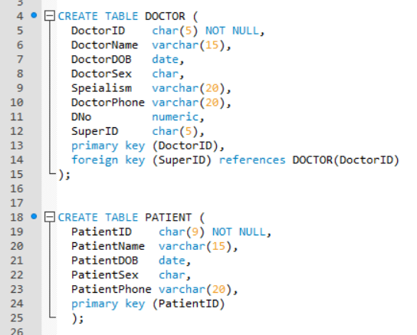

Secondly, we need to add data in ‘ClinicResdata’ SQL file. Below is the explanation,

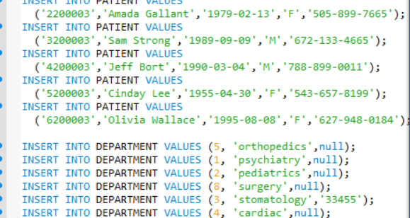

Last, we run the database and write some queries to test.

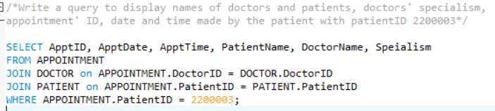

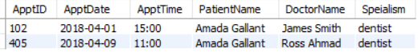

All above, there are a process of designing the Specialist Clinic Reserving database.